Usar distribuição Debian 11

sudo apt-get update -y

sudo apt-get install apache2 apache2-utils mariadb-client php7.4 libapache2-mod-php7.4 php7.4-mysql -y

sudo apt-get install php-common php7.4-cli php7.4-common php7.4-json php7.4-opcache php7.4-readline -y

sudo apt-get install php7.4-bcmath php7.4-curl php7.4-fpm php7.4-gd php7.4-xml php7.4-mbstring -y

sudo systemctl enable apache2.service

sudo chmod 777 /etc/php/7.4/apache2/php.ini

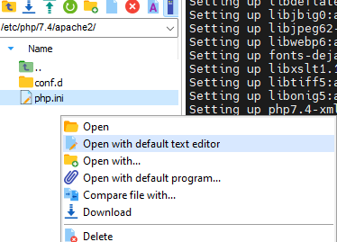

-- Alterar

max_execution_time = 60

;date.timezone = America/Sao_Paulo

Remover -> ; da linha acima

sudo chmod 644 /etc/php/7.4/apache2/php.ini

sudo systemctl restart apache2

sudo wget https://github.com/nilsteampassnet/TeamPass/archive/refs/tags/3.0.0.21.zip

sudo apt-get install zip unzip

sudo unzip 3.0.0.21.zip -d /var/www/html/

sudo mv /var/www/html/TeamPass-3.0.0.21 /var/www/html/teampass

sudo chmod -R 0777 /var/www/html/teampass/includes/

sudo chmod -R 0777 /var/www/html/teampass/includes/config

sudo chmod -R 0777 /var/www/html/teampass/includes/avatars

sudo chmod -R 0777 /var/www/html/teampass/includes/libraries/csrfp/libs

sudo chmod -R 0777 /var/www/html/teampass/includes/libraries/csrfp/log

sudo chmod -R 0777 /var/www/html/teampass/includes/libraries/csrfp/js

sudo chmod -R 0777 /var/www/html/teampass/backups

sudo chmod -R 0777 /var/www/html/teampass/files

sudo chmod -R 0777 /var/www/html/teampass/install

sudo chmod -R 0777 /var/www/html/teampass/upload